**SECTION A (60 Marks)**

Answer only **three** questions from this section.

1. An organic compound **T** on combustion yielded **13.2g** of carbon dioxide and **2.7 g** of water. When **4.7g** of **T** was vaporized at **273ᵒc** and at **760** **mmHg**, it occupied a volume of **2.4 x 10-3m3**.
2. i) Calculate empirical formula of **T**. (02 marks)

ii) Determine the molecular formula of **T**. (02½ marks)

1. **T** burns with a sooty flame. Identify **T**. (0½ mark)
2. Discuss the reactions of **T** with: (@04½ marks)
3. Bromine.
4. Propene.
5. Ethanoyl bromide.

(You answer should include conditions for the reactions and mechanisms for the reactions where possible)

1. Write equations to show how **T** can be synthesized from benzaldehyde. (01½ marks)
2. a) What is meant by the terms? (@01 mark)
3. **Order of reaction**
4. **Half – life of a reaction**

b) The **rate equation** for the reaction.





i) State how the **rate** will be affected if the concentrations of the reactants are both **doubled**. (02 marks)

ii) Describe an experiment to determine the **order of the reaction** with respect to **S2O32-** in the laboratory. (06 marks)

c) The table below shows the kinetic data for the reaction between hot aqueous potassium hydroxide and alkylbromide, C4H9Br.

|  |  |  |  |
| --- | --- | --- | --- |
| Experimental numbers | [C4H9Br]/moldm-3 | [KOH]/moldm-3 | Initial rate  /moldm-3s-1 |
| 1 | 1.0 x 10-3 | 1.0 x 10-3 | 5.0 x 10-8 |
| 2 | 2.0 x 10-3 | 1.0 x 10-3 | 1.0 x 10-7 |
| 3 | 2.0 x 10-3 | 2.0 x 10-3 | 2.0 x 10-7 |



i) Determine the **overall order** of reaction. (01 mark)

ii) Determine the **rate constant** for the reaction and state its units. (02 marks)

1. Identify the akylbromide. (0½ mark)

d) Write the mechanism for the reaction in **(c)** above. (03½ marks)

e) Draw a well **labeled energy level diagram** for the reaction mechanism illustrated in **(d)** above. (03 marks)

1. Carbon, silicon, germanium, tin and lead are elements of Group (IV) of the periodic Table.
2. Write the **electronic configuration** of the outer most energy level of group (IV) elements. (01 mark)
3. Describe how;
4. **Carbon**, **silicon** and **lead** react with **water**. (06 marks)
5. **Oxides** of the elements in b (i) react with sodium hydroxide. (08 marks)
6. Dilute nitric acid was added to trileadtetraoxide (Pb3O4) and the mixture warmed.
7. State what would be **observed**. (01 mark)
8. Write **equation** for the reaction that took place. (01½ marks)
9. The resultant mixture in (c) above was filtered and the residue was added to a solution of manganese (II) sulphate followed by few drops of concentrated nitric acid and the mixture warmed.
10. State what would be **observed**. (01 mark)
11. Write **equation** for the reaction. (01½ marks)
12. a) i) What is meant by the term **standard enthalpy of combustion**? (01 mark)

ii) Describe an experiment that can be carried out to determine the **enthalpy of combustion of liquid cyclohexane. Diagram not required**. (05 marks)

b) The standard enthalpies of combustion of the first five straight chain alkanes are shown in the table below.

|  |  |  |  |  |  |  |
| --- | --- | --- | --- | --- | --- | --- |
| Number of carbon atom | 0 | 1 | 2 | 3 | 4 | 5 |
| Enthalpy of combustion of alkanes,**-**∆HC (KJmol-1) | 286 | 890 | 1560 | 2220 | 2877 | 3509 |
| Enthalpy of combustion of alkanols,**-**∆HC (KJmol-1) | 0 | 715 | 1371 | 2010 | 2673 | 3305 |

1. Plot a graph of the **enthalpies of combustion of alkanes** against **number of carbon atoms**. (03 marks)
2. **Use** the graph to determine the **enthalpy of combustion** of hexane. (01 mark)
3. Explain the shape of the graph. (03 marks)

c) Some thermo chemical data for copper, copper (I) oxide and oxygen is given below.

Sublimation energy of copper = +339.3KJmol-1

Enthalphy of formation of copper (I) oxide = -166.7KJmol-1

First ionization energy of copper = +750.0KJmol-1

Bond dissociation energy of oxygen = +498.4KJmol-1

First electron affinity of oxygen = -141.4KJmol-1

Second electron affinity of oxygen = +790.8KJmol-1

1. Define the term **standard enthalpy of formation**. (01 mark)
2. Draw an **energy level diagram** for the formation of copper (I) oxide using the enthalpy data given. (04 marks)
3. Determine the **lattice energy** of copper (I) oxide. (02marks)

**SECTION B (40 Marks)**

Answer only **two** questions from this section.

1. a) Define the following terms. (@01 mark)
2. **Colligative property**
3. **Osmotic pressure**

b) i) Describe an experiment to determine the **molecular mass** of mannitol by osmotic pressure method. (07 marks)

ii) State three **limitations** of this method. (01½ marks)

c) The table below shows the osmotic pressure of a solution of mannitol of various concentrations at **250C**.

|  |  |  |  |  |  |  |  |
| --- | --- | --- | --- | --- | --- | --- | --- |
| Concentration of the solution (gdm-3) | 1.5 | 3.0 | 4.5 | 6.0 | 7.5 | 9.0 | 10.5 |
| Osmotic pressure of the solution (atm) | 0.20 | 0.40 | 0.60 | 0.81 | 1.05 | 1.20 | 1.40 |

1. Plot a graph of **osmotic pressure** against **concentration** of the solution. (03½ marks)
2. Explain the **shape** of the graph. (03 marks)
3. Use **your graph** to determine the **relative molecular mass** of mannitol. (03 marks)
4. Write equations to show how the following conversions can be affected.



1. Propanone from propene (02½ marks)
2. Dibromoethane from ethanol (02 marks)
3. a) State **Raoult’s law**. (02 marks)

b) The vapour pressures of **n-heptane** and **n-hexane** at **50ᵒc** are **20KNm**-2 and **50KNm-2** respectively. If the mixture contains **20g** of **n-heptane** and **30g** of **n-hexane** at **50ᵒc**, calculate the;

i) **Vapour pressure** above the liquid mixture at **50ᵒc.** (04 marks)

ii) **Mole fraction** of each component in the vapour. (03 marks)

c) Liquid **A** and **B** form an ideal solution. At **25ᵒc**, the vapour pressure of pure **A** and pure **B** are **30 KNm-2** and **12 KNm-2** respectively.

1. Define an **ideal solution.** (02 marks)
2. Plot graph of vapour pressure against mole fraction of liquid A. (03 marks)
3. Use **your graph** to determine the composition of the liquid mixture when the partial vapoour pressure of **A** is equal to that of **B**. (01 mark)
4. Determine the composition of the vapour when the mole fraction of A in the liquid mixture is **0.62**. (02½ marks)
5. Sketch a well **labeled boiling point – composition diagram** of the system of liquid **A** and **B**. (02½ marks)
6. Explain each of the following observations.
7. When solid iodine crystals were added to dilute sodium hydroxide solution, the grey solid dissolves to form a pale yellow solution which turns colourless on standing.
8. When ammonium sulphate solution was mixed with sodium sulphite solution and the mixture warmed, there was effervescence of a colourless gas that turns moist red litmus paper blue.
9. When a mixture of anhydrous zinc chloride and concentrated hydrochloric acid was added to 2 – methypropan – 2 – 01, immediate cloudiness was formed but there no observable change at room temperature if the same regent was treated with propan – 1 –ol.
10. When aluminuim was added to concentrated sodium hydroxide solution, the metal dissolved with effervescence of a colourless gas that burnt with a pop sounds.
11. When methanoic acid was warmed with Fehling’s solution a red precipitate was formed whereas with ethanoic acid, there was no observal change occurs.

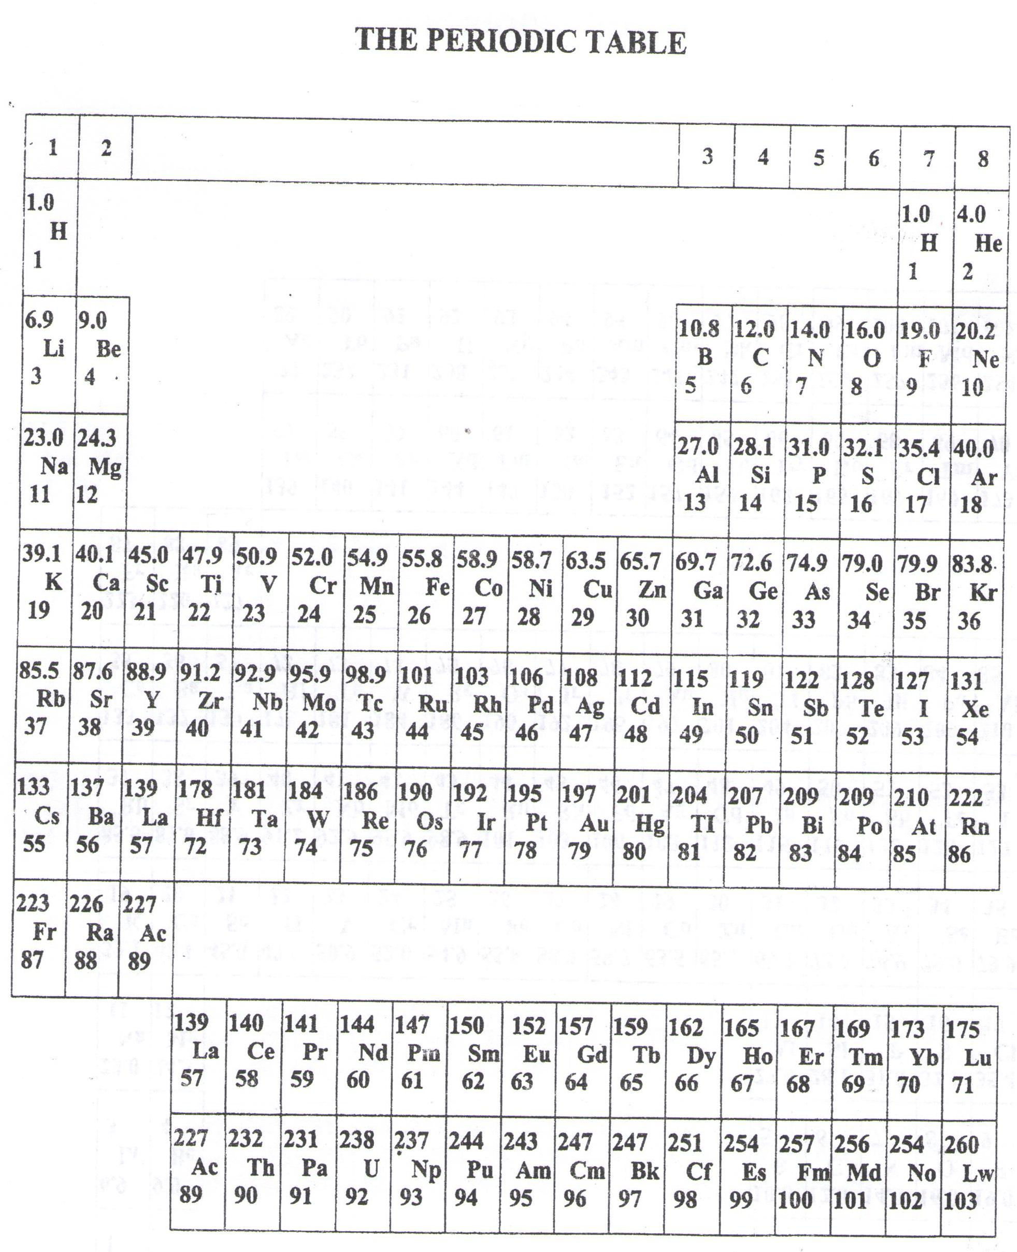

* ===END===

WELCOME TO SENIOR SIX, YEAR 2023

This is the last page of the printed paper, Page 06